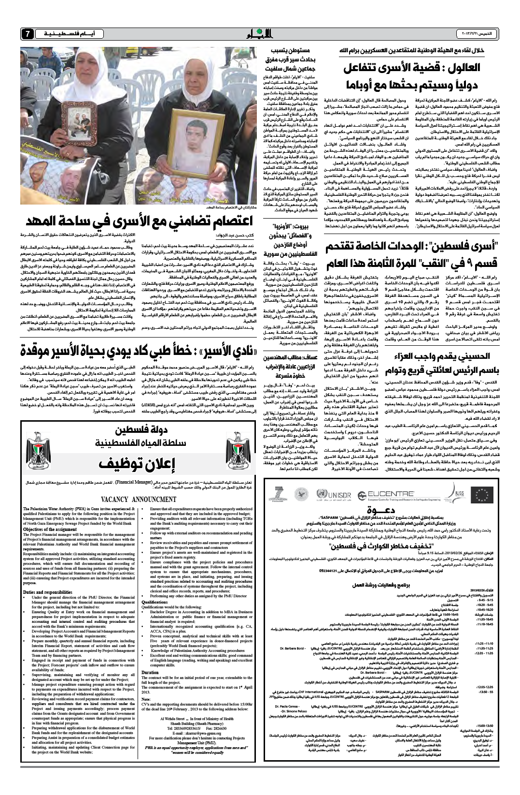

Al Ayyam newspaper Thursday 21/Feb/2013
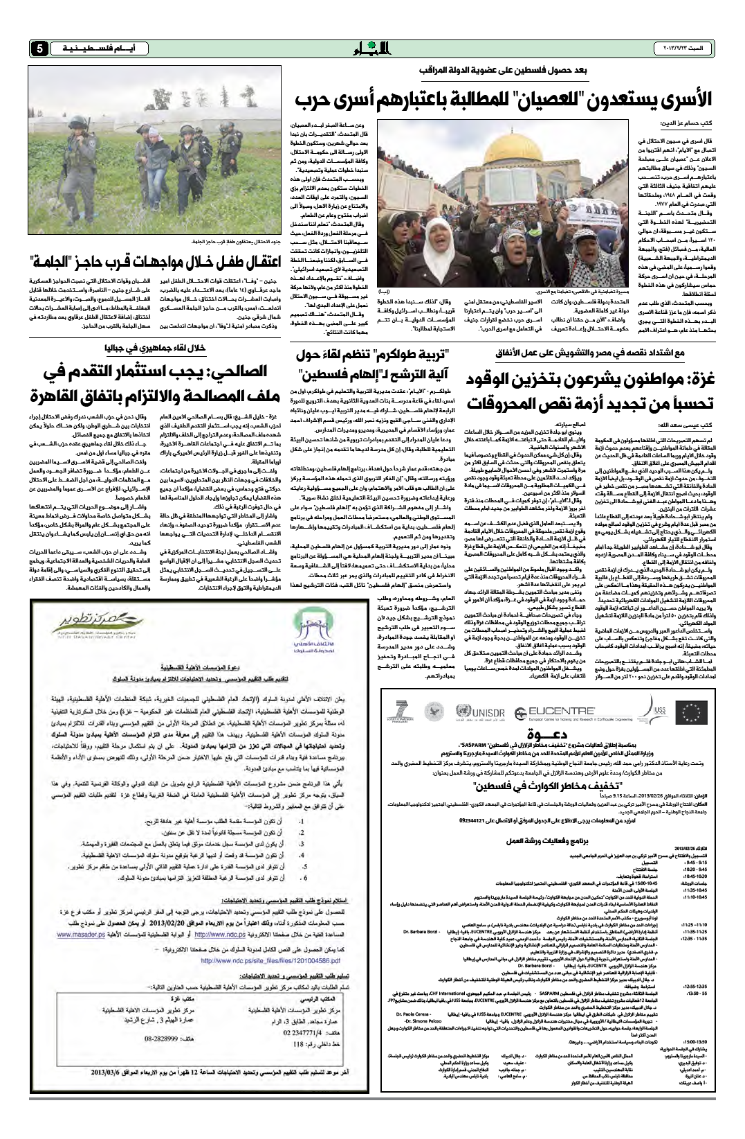

Al Ayyam newspaper Sunday 23/Feb/2013

