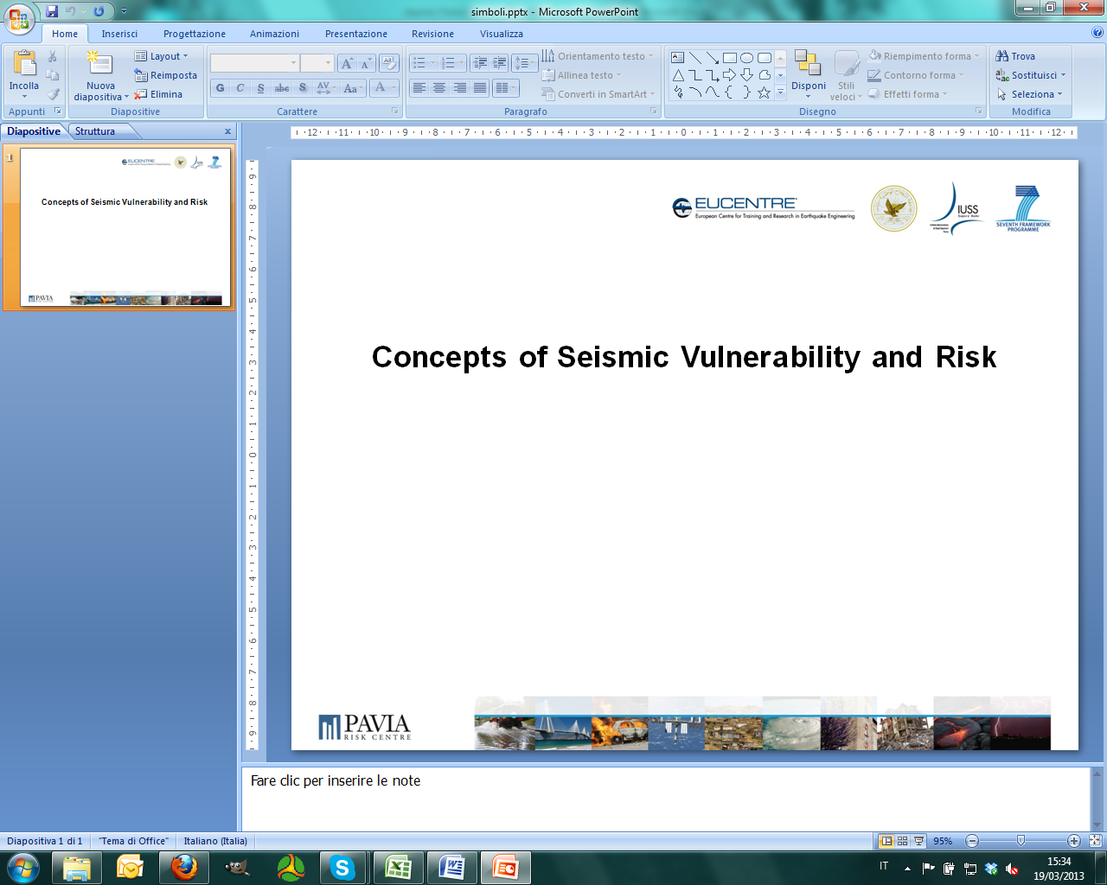

SASPARM

Support Action for Strengthening Palestinian-administrated Areas
capabilities for seismic Risk Mitigation

Call ID FP7-INCO.2011-6.2

The SASPARM Project
The project aims to reinforce the cooperation with Europe’s neighbours in the context of the European Research Area. The An-Najah National University (NNU) in the Palestinian-administered Areas (PS) is coordinating the project with the support of the European Centre for Training and Research in Earthquake Engineering (EUCENTRE) and the Institute for Advanced Study of Pavia (IUSS) in Italy.
The project activities are identified with the goal to create a research infrastructure and to develop and enhance international cooperation with PS in the field of scientific technology and capacity building, i.e. human resources, research policy, networks of researchers and research institutes. In an international framework the proposed activities will lead NNU to a fruitful cooperation with EU.
At national level an enhancement of capability will ensure PS to gain a centre prepared to respond to earthquake engineering and engineering seismology needs of the local community. The latter target will be pursued by enhancing the capability of NNU for training activity in the field of earthquake engineering. Furthermore, a higher visibility of NNU will encourage researchers to compete internationally in terms of scientific excellence (e.g., acquiring and participating in EU Framework projects related to seismic risk reductions) and increase their incentives to continue their research activities in PS.

Course Objectives
The course modules aim at increasing the role of NNU in the field of seismic risk mitigation in the national, regional and international panorama. Training modules and exchange of knowledge for NNU personnel, young students and practitioners will be fundamental ingredients for increasing the project visibility and improving the competitiveness of all partners. In addition, the reinforced research capacities of NNU will allow the organisation of effective training in local community on disaster risk reduction and emergency preparedness.
The SASPARM training modules have been organised taking direct advantage of the long experience of IUSS and EUCENTRE running international level Doctoral and Master Programmes in Earthquake Engineering and Engineering Seismology, with (Erasmus Mundus – MEEES Programme, www.meees.org) and without (Understanding and Managing Extremes, UME School, www.umeschool.it) mobility.

Who can benefit from the courses?
There are two types of courses: i) courses for practitioners and ii) courses for young researchers and students. The courses scheduled for young researchers and students are also open to practitioners.
Course Modules for Practitioners

Module 1: Fundamentals of seismic analysis and seismic design

Lecturer
Dr. Barbara Borzi

Day 1:
09:00 −10:30: Fundamentals of seismology
10:30 − 11:00: Coffee break
11:00 − 12:30: Seismic hazard in Palestine
12:30 – 14:30: Lunch break

14:30 − 16:00: Single Degree of Freedom System (SDOF)
16:00 − 16:30: Coffee break
16:30 − 19:00: Elastic Response Spectrum – Site effects EC8

Day 2:
09:00 – 10:30: Fundamental of ductility and Inelastic Response Spectra
10:30 − 11:00: Coffee break
11:00 − 12:30: Conceptual seismic design
12:30 − 14:30: Lunch break

14:30 − 16:00: Seismic Analysis
16:00 − 16:30: Coffee break
16:30 − 19:00: Capacity Design of Buildings

Day 3:
09:00 − 10:30: Assignment 1
10:30 − 11:00: Coffee break
11:00 − 13:00: Assignment 2
Module 2: Seismic design according to codes used in Palestine (UBC 97, Jordanian Seismic Building Code)

Lecturer
Dr. Jalal Al-Dabbeek

Day 4:

09:00 − 10:30: Seismic hazard according to code regulations
10:30 − 11:00: Coffee break
11:00 − 12:30: Seismic site effect according to code regulations
12:30 – 14:30: Lunch break

14:30 − 16:00: Seismic forces and building codes. Equivalent lateral force method according to code regulations
16:00 − 16:30: Coffee break
16:30 − 18:00: General note about geotechnical and foundation, seismic design considerations

Day 5:

09:00 − 10:30: The influence of architectural and structural configuration on seismic performance of buildings
10:30 − 11:00: Coffee break
11:00 − 12:30: Application on the seismic vulnerability of Palestinian common buildings
12:30 – 14:30: Lunch break

14:30 − 16:00: Assignment 1
16:00 − 16:30: Coffee break
16:30 − 18:00: Assignment 2

Day 6:

09:00 − 10:30: Assignment 3
10:30 − 11:00: Coffee break
11:00 − 12:30: Assignment 4
12:30 – 14:30: Lunch break

14:30 − 16:00: Structural details
16:00 − 16:30: Coffee break
16:30 − 18:00: Special topics on earthquake engineering (seismic retrofit and upgrading fundamentals,..etc)

Corse Modules for young researchers and students

Module 1: Fundamentals of seismic vulnerability and seismic risk

Lecturers
Dr. Jalal Al-Dabbeek, Dr. Barbara Borzi, Dr. Paola Ceresa

Day 1:
09:30 − 10:30: Concepts of vulnerability
10:30 − 11:30: Mathematical definitions of vulnerability and risk
11:30 − 14:30: Application 1, Application 2, Application 3, Application 4, and Application 5
Module 2: Fundamentals of structural dynamics

Lecturer
Dr. Alessandro Dazio

Day 1:
09:00 − 10:30: Introduction. SDoF systems: Equation of motion and modelling
10:30 − 11:00: Coffee break
11:00 − 12:30: Free vibrations
12:30 − 14:30: Lunch break

14:30 − 16:00: Assignment 1
16:00 − 16:30: Coffee break
16:30 − 18:00: Assignment 1

Day 2:
09:00 − 10:30: Harmonic excitation
10:30 − 11:00: Coffee break
11:00 − 12:30: Transfer functions
12:30 − 14:30: Lunch break

14:30 − 16:00: Forced vibrations
16:00 − 16:30: Coffee break
16:30 − 18:00: Forced vibrations

Day 3:
09:00 − 10:30: Seismic excitation (Part 1)
10:30 − 11:00: Coffee break
11:00 − 12:30: Seismic excitation (Part 2)
12:30 − 14:30: Lunch break

14:30 − 16:00: Assignment 2
16:00 − 16:30: Coffee break
16:30 − 18:00: Assignment 2

Day 4:
09:00 − 10:30: MDoF systems: Equation of motion
10:30 − 11:00: Coffee break
11:00 − 12:30: Free vibrations
12:30 − 14:30: Lunch break

14:30 − 16:00: Damping
16:00 − 16:30: Coffee break
16:30 − 18:00: Forced vibrations

Day 5:
09:00 − 10:30: Seismic excitation (Part 1)
10:30 − 11:00: Coffee break
11:00 − 12:30: Seismic excitation (Part 2)
12:30 − 14:30: Lunch break

14:30 − 16:00: Assignment 3
16:00 − 16:30: Coffee break
16:30 − 18:00: Assignment 3
Module 3 : Ground response analyses and near-surface site characterization

Lecturer
Prof. Carlo G. Lai and Dr. Maria-Daphne Mangriotis

Day 1
09:00 − 10:30: Fundamentals of wave propagation (Part 1)
10:30 − 11:00: Coffee break
11:00 − 12:30: Fundamentals of wave propagation (Part 2)
12:30 − 14:30: Lunch break

14:30 − 16:00: Ground response analyses (Part 1)
16:00 − 16:30: Coffee break
16:30 − 18:30: Case study and exercising

Day 2
09:00 − 10:30: Ground response analyses (Part 2)
10:30 − 11:00: Coffee break
11:00 − 12:30: Near-surface site characterization using seismic methods (invasive techniques)
12:30 − 14:30: Lunch break

14:30 − 16:00: Near-surface site characterization using seismic methods (non-invasive techniques)
16:00 − 16:30: Coffee break
16:30 − 18:30: Review of Fourier analysis and discrete inverse theory

Day 3
09:00 − 10:30: Seismic prospecting using active SASW/MASW techniques (Part 1)
10:30 − 11:00: Coffee break
11:00 − 12:30: Seismic prospecting using active SASW/MASW techniques (Part 2)
12:30 − 14:30: Lunch break

14:30 − 15:30: Seismic prospecting using passive MASW, ReMi and H/V techniques
15:30 − 16:45: Case study using real and synthetic geophysical seismic data
Module 4 : Basic of signal processing, design of a specimens, system acquisition

Lecturer
Dr. Simone Peloso

Day 1:
09:00 − 10:30: Basic of Sensor and Transducers (Part 1)
10:30 − 11:00: Coffee break
11:00 − 12:30: Basic of Sensor and Transducers (Part 2)
12:30 − 14:30: Lunch break

14:30 − 16:00: Description of Actuation Systems (Part 1)
16:00 − 16:30: Coffee break
16:30 − 18:00: Description of Actuation Systems (Part 1)

Day 2:
09:00 − 10:30: Description of Actuation Systems (Part 2)
10:30 − 11:00: Coffee break
11:00 − 12:30: Analysis of Signal (Part 1)
12:30 − 14:30: Lunch break

14:30 − 16:00: Analysis of Signal (Part 2)
16:00 − 16:30: Coffee break
16:30 − 18:00: Analysis of Signal (Part 2)

Day 3:
09:00 − 10:30: Scaling Strategy (Part 1)
10:30 − 11:00: Coffee break
11:00 − 12:30: Scaling Strategy (Part 2)
12:30 − 14:30: Lunch break

14:30 − 16:00: Testing Strategy
16:00 − 16:30: Coffee break
16:30 − 18:00: Testing Strategy

The researchers of NNU with the support of Eucentre and IUSS will train students, also with the support of the new laboratory equipment, to understand the dynamic of structures. A comparison of experimental response of a specimen prepared by NNU personnel will be compared with the analytical responses computed, for example, with Matlab.

Project Coordinator
Dr. Jalal Al Dabbeek
An-Najah National University (NNU)

Lecturers
Dr. Jalal Al Dabbeek
An-Najah National University (NNU)

Dr. Barbara Borzi
European Centre for Training and Research in Earthquake Engineering (EUCENTRE)

Prof. Carlo G. Lai
University of Pavia, Department of Civil and Architectural Engineering
European Centre for Training and Research in Earthquake Engineering (EUCENTRE)

Dr. Simone Peloso
European Centre for Training and Research in Earthquake Engineering (EUCENTRE)

Dr. Paola Ceresa
UME School, Institute for Advanced Study of Pavia (IUSS)

Dr. Alessandro Dazio
UME School, Institute for Advanced Study of Pavia (IUSS)

Dr. Maria-Daphne Mangriotis
Heriot-Watt University
European Centre for Training and Research in Earthquake Engineering (EUCENTRE)

www.sasparm.ps
www.najah.edu
www.eucentre.it
www.iusspavia.it
www.umeschool.it

